**South Sudan Baseline Household Survey – Descriptive Analysis of Weights**

We have two versions of weights. The first version (final_wt1) uses household populations in each enumeration area (EA) taken from NBS data. The second version (final_wt2) uses an estimate based on estimates from UN population data and an average household size of 6.

Reviewing descriptive statistics for all the weights together, we can see that the MSI weights are larger. The MSI weights have three values in Pibor County that are quite large (i.e., greater than 300). This is affecting the mean, standard deviation, and maximum value.

Table 1: Overall Descriptive Statistics for Weights

|  |  |  |  |  |  |  |  |
| --- | --- | --- | --- | --- | --- | --- | --- |
| **County** | **Weight** | **N** | **Mean** | **Median** | **St. Dev.** | **Min. Val.** | **Max. Val.** |
| Overall | final_wt1 (NBS) | 218 | 33.7 | 17.6 | 39.5 | 2.3 | 339.4 |
| final_wt2 (MSI) | 218 | 64.3 | 18.4 | 382.6 | 1.4 | 5605.5 |

Figure 1: Overall Histogram of Weights

In Akobo County, the weights are similar. While NBS weights have a higher mean and median, the MSI weights have a larger maximum value. The weights have similar standard deviations.

Table 2: Akobo County Descriptive Statistics for Weights

|  |  |  |  |  |  |  |  |
| --- | --- | --- | --- | --- | --- | --- | --- |
| **County** | **Weight** | **N** | **Mean** | **Median** | **St. Dev.** | **Min. Val.** | **Max. Val.** |
| Akobo | final_wt1 (NBS) | 37 | 18.4 | 17.2 | 11.1 | 4.6 | 58.2 |
| final_wt2 (MSI) | 37 | 15.7 | 14.6 | 11.8 | 2.9 | 69.3 |

Figure 2: Akobo County Histogram of Weights

In Budi County, the MSI weights are larger than the NBS weights in terms of the mean, median, standard deviation, and maximum value.

Table 3: Budi County Descriptive Statistics for Weights

|  |  |  |  |  |  |  |  |
| --- | --- | --- | --- | --- | --- | --- | --- |
| **County** | **Weight** | **N** | **Mean** | **Median** | **St. Dev.** | **Min. Val.** | **Max. Val.** |
| Budi | final_wt1 (NBS) | 37 | 21.0 | 14.8 | 16.9 | 2.3 | 78.9 |
| final_wt2 (MSI) | 37 | 28.9 | 18.7 | 28.8 | 2.4 | 127.0 |

Figure 3: Budi County Histogram of Weights

In Duk County, the MSI weights are larger than the NBS weights in terms of the mean, standard deviation, and maximum value, though the median is larger for the NBS weights.

Table 4: Duk County Descriptive Statistics for Weights

|  |  |  |  |  |  |  |  |
| --- | --- | --- | --- | --- | --- | --- | --- |
| **County** | **Weight** | **N** | **Mean** | **Median** | **St. Dev.** | **Min. Val.** | **Max. Val.** |
| Duk | final_wt1 (NBS) | 33 | 14.0 | 8.9 | 14.6 | 2.6 | 70.7 |
| final_wt2 (MSI) | 33 | 21.6 | 7.8 | 35.4 | 2.4 | 179.1 |

Figure 4: Duk County Histogram of Weights

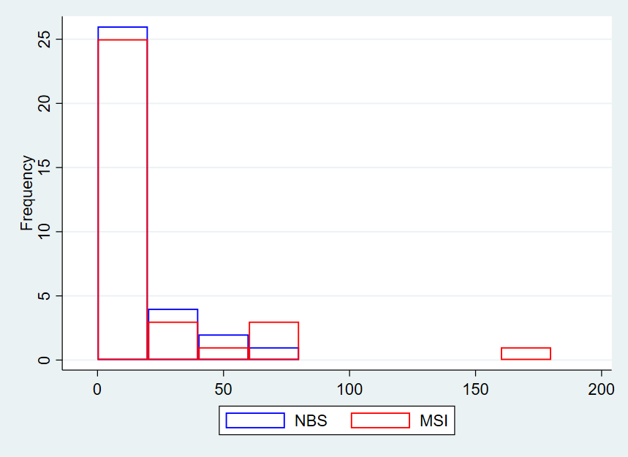

In Leer County, the weights are similar in terms of mean, median, and standard deviation. The MSI weights have a larger maximum value.

Table 5: Leer County Descriptive Statistics for Weights

|  |  |  |  |  |  |  |  |
| --- | --- | --- | --- | --- | --- | --- | --- |
| **County** | **Weight** | **N** | **Mean** | **Median** | **St. Dev.** | **Min. Val.** | **Max. Val.** |
| Leer | final_wt1 (NBS) | 37 | 9.2 | 7.5 | 7.0 | 2.4 | 37.3 |
| final_wt2 (MSI) | 37 | 9.9 | 6.8 | 10.1 | 1.4 | 57.9 |

Figure 5: Leer County Histogram of Weights

In Pibor County, the MSI weights are larger than the NBS weights in terms of the mean, standard deviation, and maximum value. The two weights had similar medians.

Table 6: Pibor County Descriptive Statistics for Weights

|  |  |  |  |  |  |  |  |
| --- | --- | --- | --- | --- | --- | --- | --- |
| **County** | **Weight** | **N** | **Mean** | **Median** | **St. Dev.** | **Min. Val.** | **Max. Val.** |
| Pibor | final_wt1 (NBS) | 37 | 73.8 | 64.8 | 60.6 | 12.1 | 339.4 |
| final_wt2 (MSI) | 37 | 236.0 | 62.7 | 916.0 | 3.6 | 5605.5 |

Figure 6: Pibor County Histogram of Weights

In Uror County, the MSI weights are larger than the NBS weights in terms of the mean, standard deviation, and maximum value.

Table 7: Uror County Descriptive Statistics for Weights

|  |  |  |  |  |  |  |  |
| --- | --- | --- | --- | --- | --- | --- | --- |
| **County** | **Weight** | **N** | **Mean** | **Median** | **St. Dev.** | **Min. Val.** | **Max. Val.** |
| Uror | final_wt1 (NBS) | 37 | 63.9 | 57.3 | 33.2 | 17.0 | 141.9 |
| final_wt2 (MSI) | 37 | 69.1 | 60.9 | 47.3 | 14.1 | 212.1 |

Figure 7: Uror County Histogram of Weights

